Room A
AQ1 Breast DCIS.
Stem: 55y postmenopausal female with no past medical or surgical history is referred to the office for calcifications seen in the upper outer quadrant of the left breast on annual screening mammogram that weren’t appreciated on the mammogram the year prior. She denies any changes in her breasts or axillae.
Family history is negative for breast or gynecologic malignancies.
Her physical exam is unremarkable.

What is your Differential Dx?
- DCIS
- LCIS
- Invasive breast cancer
- Atypical ductal or lobular hyperplasia
- Fibrocystic changes
- Fat necrosis

Additional Workup or Studies?

- Diagnostic mammogram : Fine linear branching calcifications located near the chest wall in the upper, outer quadrant of the left breast; the calcifications appear focal and do not appear to be multicentric
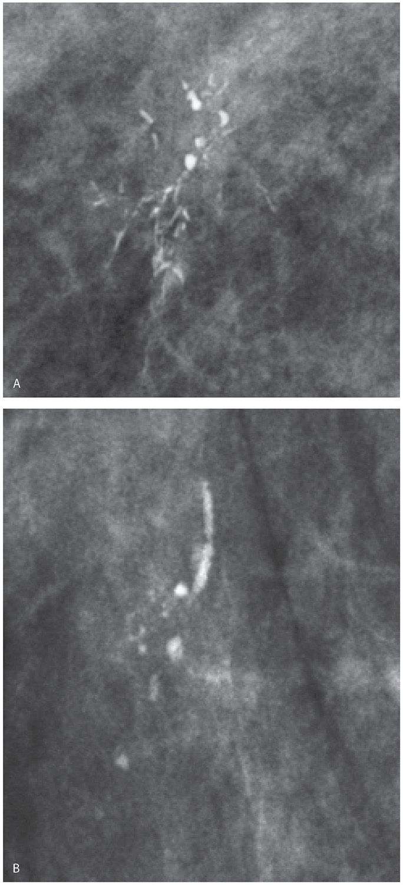

- Stereotactic core needle biopsy: Returns as DCIS

What would you like to do now?
- Surgery:
    - Localization
    - Breast conserving surgery with postoperative radiation (no SLNB)
    - (or) Simple mastectomy with sentinel lymph node biopsy +/- reconstruction

Pathology returns as ER/PR + high grade DCIS, what treatment you would recommend?
5 years of anastrozole

Describe Breast Conserving Surgery
- Preprocedural localization of nonpalpable lesions.
- Plan incision on lesion depth and location, with consideration of future mastectomy incision.
- Excise the localized lesion with grossly normal 1-cm margins.
- Orient specimen and send to mammography to ensure the wire, clip, and lesion or calcifications are in the specimen.
- Palpate the cavity for any suspicious tissue.
- Ensure hemostasis and close.

AQ2 Appendiceal Carcinoid
Stem: A previously healthy 68-year-old woman is seen in the ED with 18 hours of RLQ abdominal pain and CT findings showing acute appendicitis without perforation, abscess, or phlegmon. You proceeded with laparoscopic appendectomy, patient does well and goes home on POD 1.
Now she is in the clinic for post op, the pathology report had just been signed and released while she was waiting to be roomed. When you walk in to see her, she is obviously distressed and asking you “What is the plan, pathology is showing “tumor”” … She is crying.
Laparoscopic or Open Appendectomy (Describe

You pull the pathology report, and it shows …
- 6mm well circumscribed carcinoid tumor near tip of appendix with no lymphovascular invasion or evidence of perforation ?
  - Reassure, Nothing further
- Path Returns with 14mm well carcinoid tumor at mid appendix with lymphovascular invasion

- PET-Dotatate or Octreotide scan post op, with tumor markers
- Right Colectomy (Describe)
-Open , lap or robotic
- Examine peritoneal surfaces, liver.
- Mobilize the right colon from lateral to medial or medial to lateral
- Enter lesser sac at hepatic flexure.
- separate omentum from transverse colon.
- Divide mesentery.
- Ligate ileocolic vascular pedicle. (Could be done before mobilizing the colon especially with medial to lateral mobilization) -
- Construct ileocolic anastomosis.
- Close mesenteric defect (surgeon preference).

- Path Returns with 34mm well-circumscribed carcinoid tumor at mid appendix without evidence of perforation or lymphovascular invasion.

  - Right colectomy
4. Pathology returns with adenocarcinoma:

  - Stage the patient with CT C/A/P
  - CEA level
  - Colonoscopy if no recent one
  - Right colectomy
- What if, there is a mucinous mass involving the base of the appendix. During mobilization and right colectomy there is spillage of mucin. What next?
Referral for evaluation for HIPEC.
AQ3 Abdominal Wall Reconstruction
Stem: 56-year-old obese (BMI 41 kg/m2) male who 3 y ago underwent an elective Sigmoidectomy.
He developed a postoperative wound infection and his wound healed by secondary intention. He developed incisional hernia and underwent elective open repair.
He initially did well but on 2-week postoperative visit, he developed wound infection and was explored in the operating room, the wound was opened, the fascia appeared intact, and cultures revealed MRSA. He was placed on a negative pressure wound therapy for approximately 6 months.
He now has a chronic draining sinus, he reports generalized malaise, denies fevers
PE: No erythema on exam
CT Abd reveals fluid around the mesh
Labs: Unremarkable.
Past medical history of hypertension and non–insulin-dependent diabetes

What is your differential diagnosis?
- Infected foreign body eg suture.
- infected graft and lack of incorporation
- Mesh erosion
- EC Fistula

How would you manage this patient?
- Obtain operative reports.
  - What would you like to know?
    - Type of Mesh
      - Composix mesh (polypropylene and PTFE).
What would you do ? And how does the type of mesh affect your decision?

- More than 6 months since placement, no role for further conservative management
- Plan for exploration / mesh extraction
  - macroporous mesh (polypropylene and polyester mesh) can often be salvaged with partial mesh excision
  - Microporous mesh (ePTFE, GORE-TEX) can almost never be salvaged and requires complete mesh excision.

How would you repair the large remaining defect after you extract the mesh?

Component separation

Describe:

- Remove all prosthetic material.
- Address any bowel issues as necessary.
- Adhesiolysis of the entire anterior abdominal wall to the paracolic gutters to allow muscular components to slide to the midline during reconstruction.
- Elevate lipocutaneous flaps 2 cm lateral to the linea semilunaris, edge of the rectus muscle.
- Incise the external oblique fascia and separate the external and internal oblique muscles in their avascular plane.
- Continue the dissection 3–4 cm above the costal margin and inferiorly to the inguinal ligament.
- Release the posterior rectus sheath by making an incision 1 cm lateral to the linea alba.
- Develop the retromuscular plane out to the linea semilunaris while preserving the neurovascular bundles to the rectus muscle.
- Place an appropriately sized biologic graft as an underlay, redistributing tension across the graft to help medialize the rectus complex.
- Drains placed over the mesh.
- Midline fascia reapproximated with interrupted figure-of-8 sutures.
- Remove excess devascularized skin, and close over multiple drains.

